**PROJECT REPORT**

**Part-2:Homeaway**

***HOME PAGE***



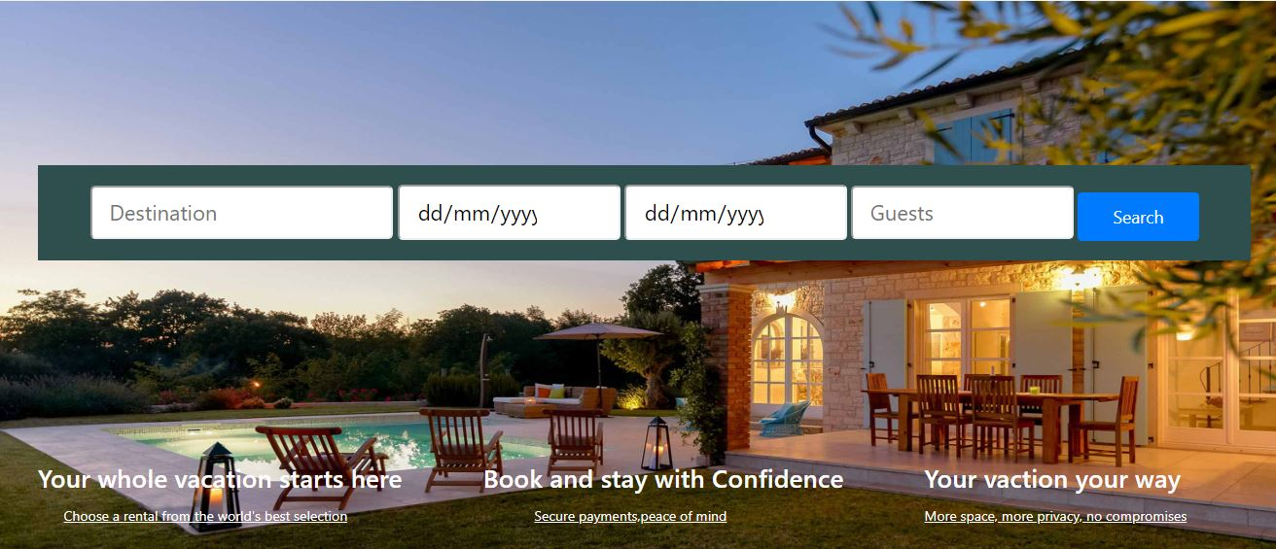

Owner Module:

1) Login

i) Unsuccessful Login: Entering wrong email or password

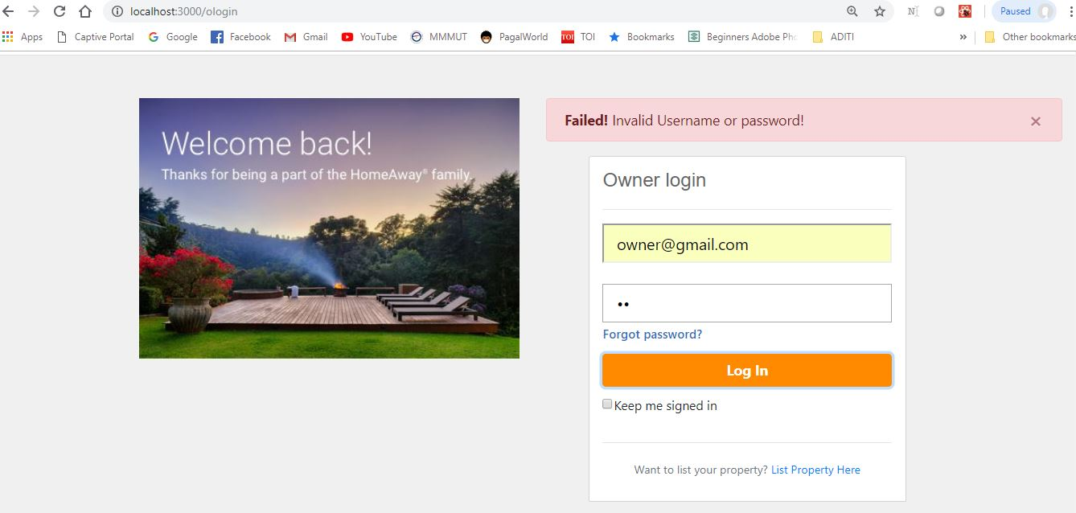

Server Output:

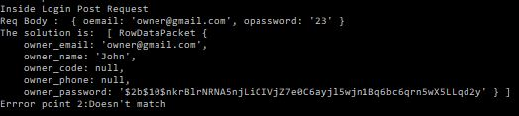

ii) Successful Login

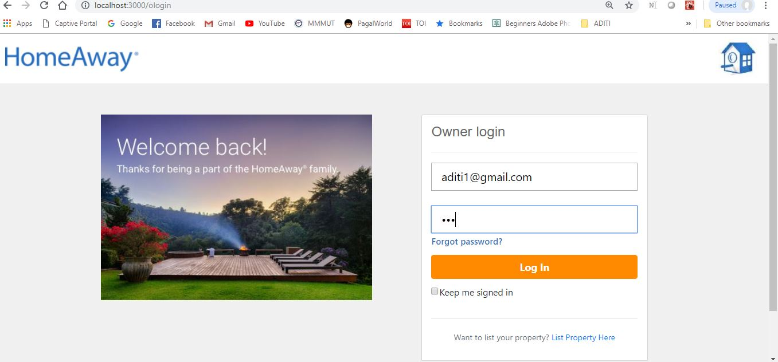

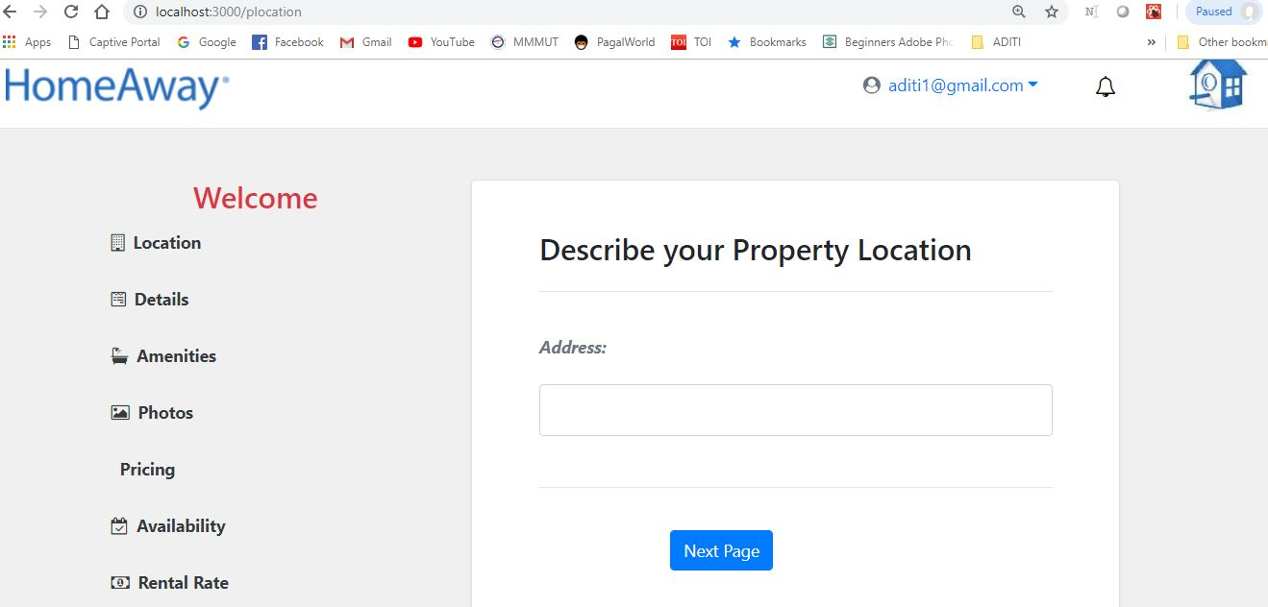

Server Output:

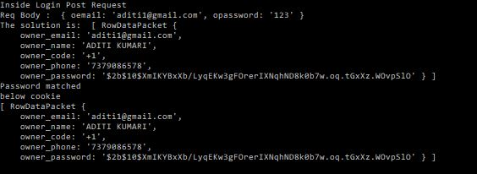

Route Code for Login:

app.post('/ologin',function(req,res){

console.log("Inside Login Post Request");

console.log("Req Body : ",req.body);

var flag=0;

oemail=req.body.oemail;

opassword=req.body.opassword;

pool.getConnection(function(err,con) {

if (err)

throw err;

con.query('SELECT * FROM Owner WHERE owner_email = ?',[oemail], function (error, results, fields) {

if (error) {

console.log("error ocurred",error);

// res.send({

// "code":400,

// "failed":"error ocurred"

// })

}else{

console.log('The solution is: ', results);

if(results.length >0){

if(bcrypt.compareSync(opassword,results[0].owner_password))

{

console.log("Password matched")

flag=1;

}

// Start of error 2

else{

console.log("Errror point 2:Doesn't match")

// res.send({

// "code":204,

// "failed":"Email and password does not match"

// });

}

// end of error 2

}

else{

console.log("errror point 3:No such Email")

// res.send({

// "code":204,

// "failed":"Email does not exits"

// });

}

}

if (flag){

res.cookie('cookie',oemail,{maxAge: 900000, httpOnly: false, path : '/'});

console.log("below cookie")

req.session.user = results;

console.log(req.session.user)

res.send({

"code":200,

"success":"login sucessfull"

});

}

//}

});

});

});

2) Signup

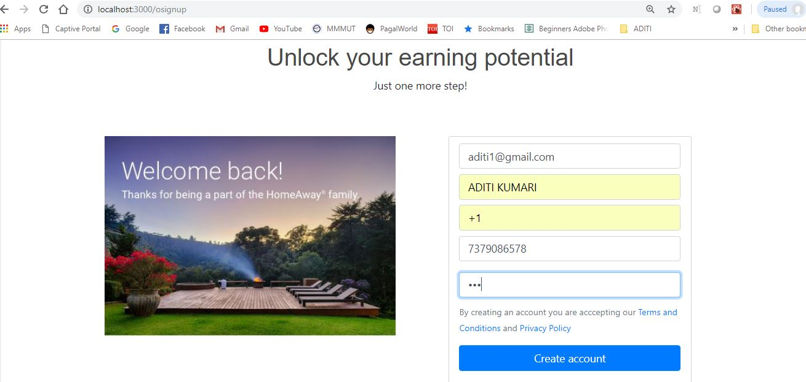

On successful registration:

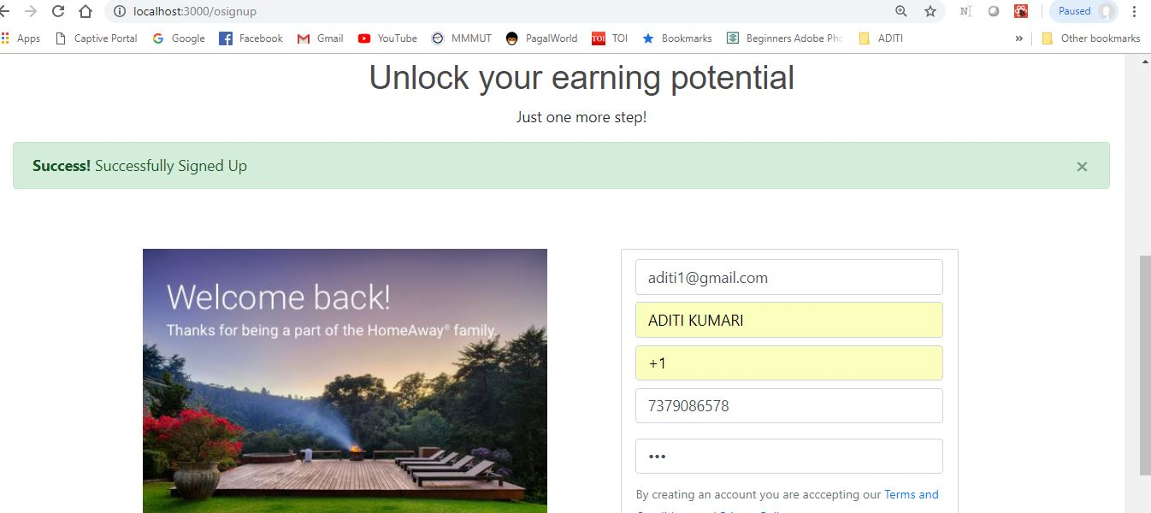

Route Code for Registration:

app.post('/osignup',function(req,res){

console.log("Inside Signup Post Request");

console.log("Req Body : ",req.body);

let hash = bcrypt.hashSync(req.body.opassword, 10);

console.log(hash);

var sql="insert into Owner values("+mysql.escape(req.body.oemail)+","+mysql.escape(req.body.oname)+","+mysql.escape(req.body.ocode)+","+mysql.escape(req.body.ophone)+","+mysql.escape(hash)+");"

pool.getConnection(function(err,con) {

if (err)

throw err;

console.log("Connected!");

con.query(sql,function(err,result){

if(err){

console.log("Error inserting data")

res.send({

"code":400,

"failed":"error ocurred"

})

}

else{

console.log("Successful")

res.send({

"code":200,

"success":"login sucessfull"

});

}

});

});

});

Server Output:

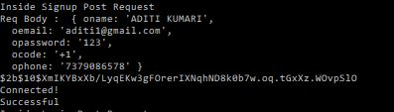

3) Post Property

Entering details for property listing:

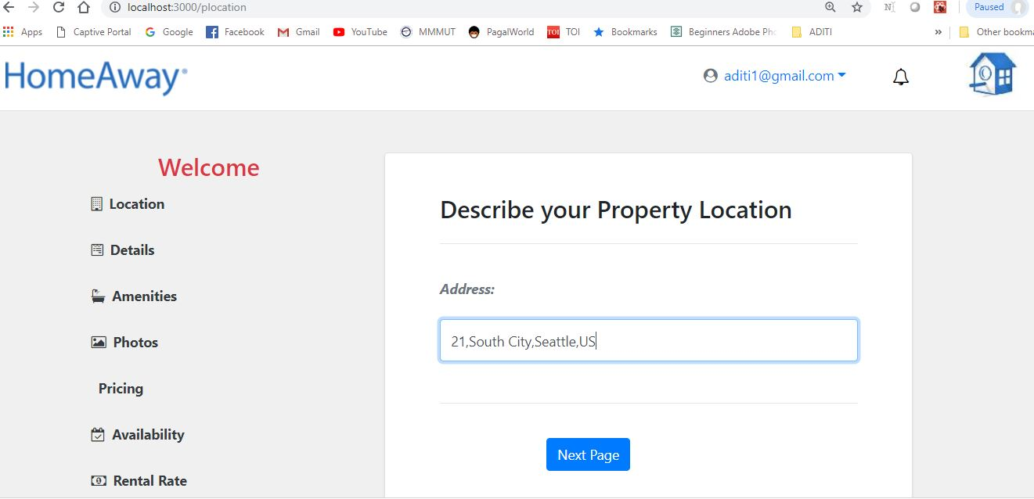

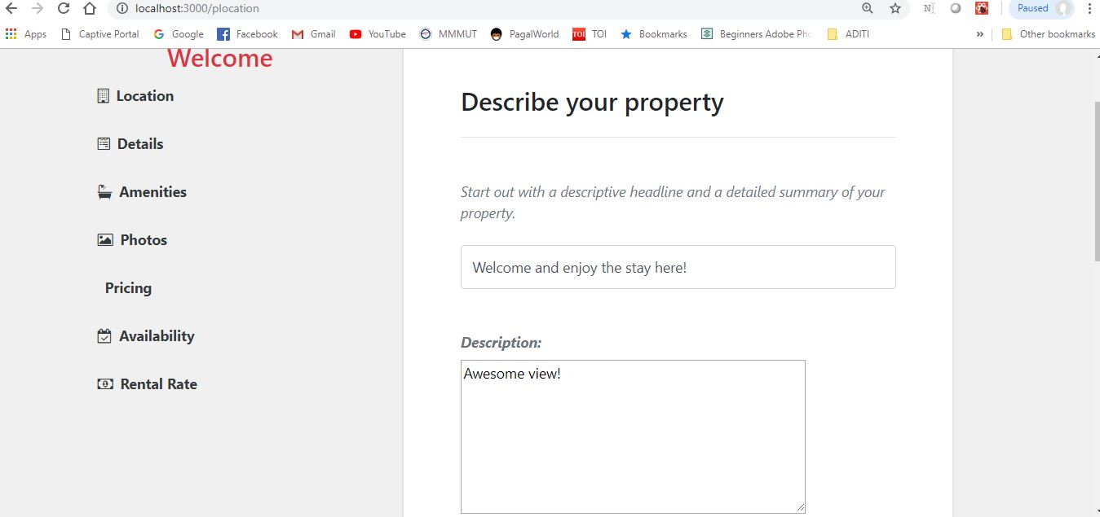

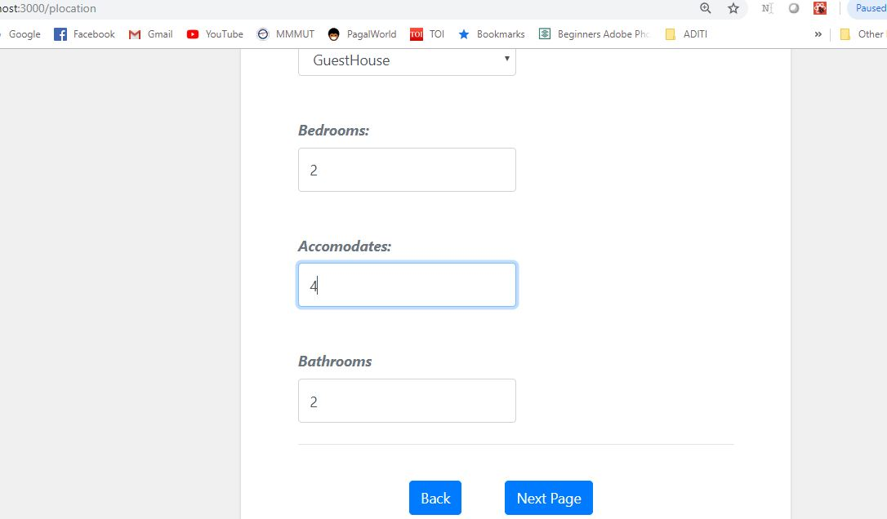

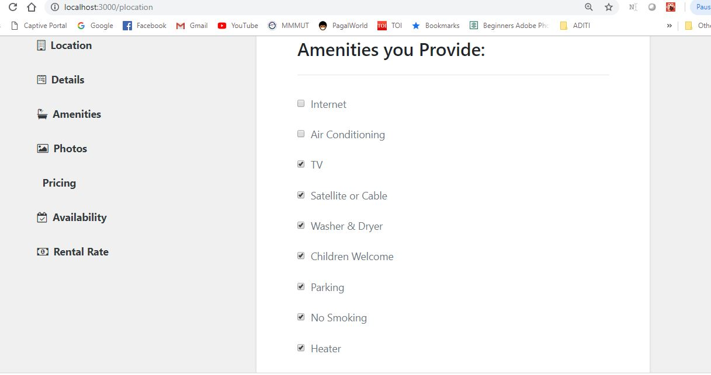

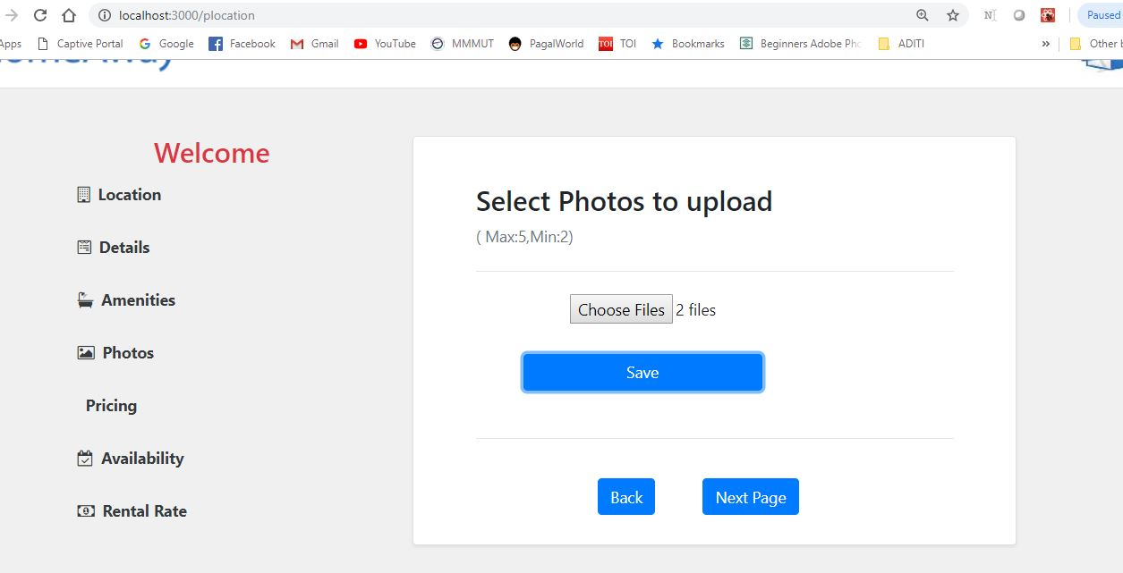

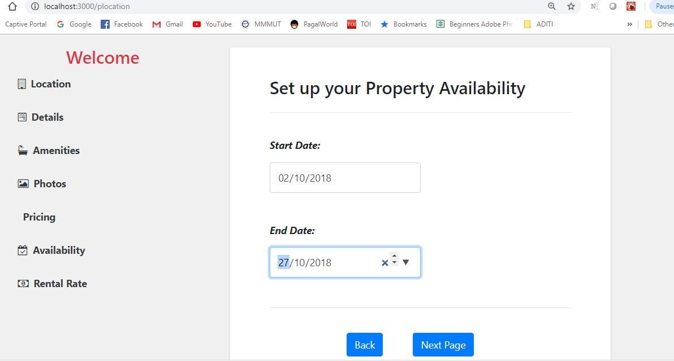

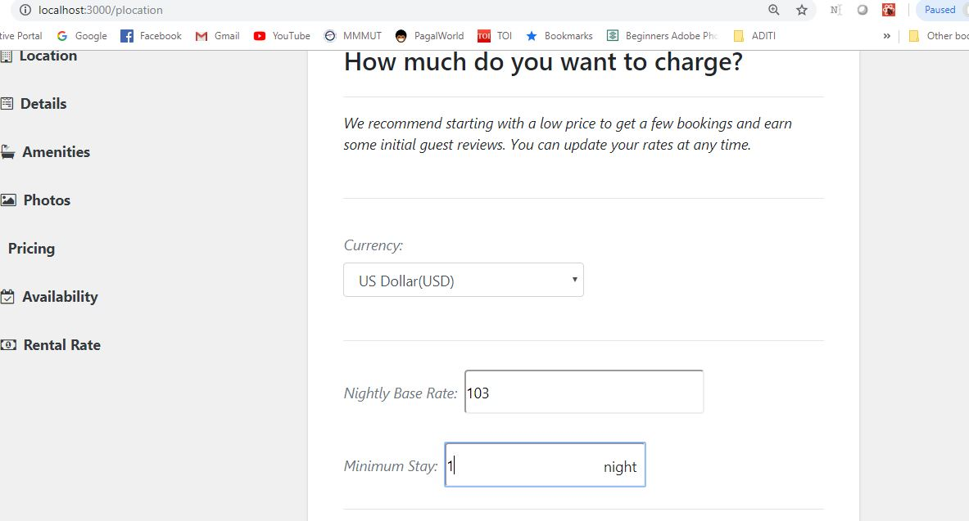

On Successful Listing of property:

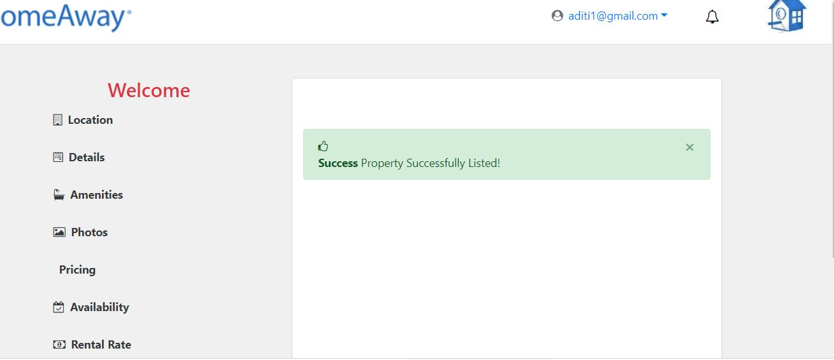

Route Code:

app.post('/property',function(req,res){

console.log("Inside Signup Post Property Request");

console.log("Req Body : ",req.body);

var am="["+req.body.amenities+"]"

var pic="["+req.body.a+"]"

var sql="insert into property(oemail,location,headline,detail,propertytype,bedroom,bathroom,accomodate,startdate,enddate,currency,stay,rate,facility,image) values("+mysql.escape(req.body.email)+","+mysql.escape(req.body.location)+","+

mysql.escape(req.body.headline)+","+mysql.escape(req.body.describe)+","+mysql.escape(req.body.propertytype)+","+mysql.escape(req.body.bedrooms)+","+mysql.escape(req.body.bathrooms)+","+mysql.escape(req.body.accomodates)+","+mysql.escape(req.body.startday)+","+mysql.escape(req.body.endday)+","+mysql.escape(req.body.currency)+","+mysql.escape(req.body.stay)+","+mysql.escape(req.body.rate)+","+mysql.escape(am)+","+mysql.escape(pic)+");"

console.log(sql)

pool.getConnection(function(err,con) {

if (err)

throw err;

console.log("Connected!");

con.query(sql,function(err,result){

if(err){

console.log("Error inserting data")

res.send({

"code":400,

"failed":"error ocurred"

})

}

else{

console.log("Successful")

res.send({

"code":200,

"success":"login sucessfull"

});

}

});

});

});

Server Output:

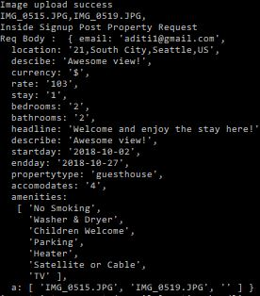

C:\Users\ADITI KUMARI\Desktop\screen\n2.JPG

4) View Property

User Module:

1) Signup

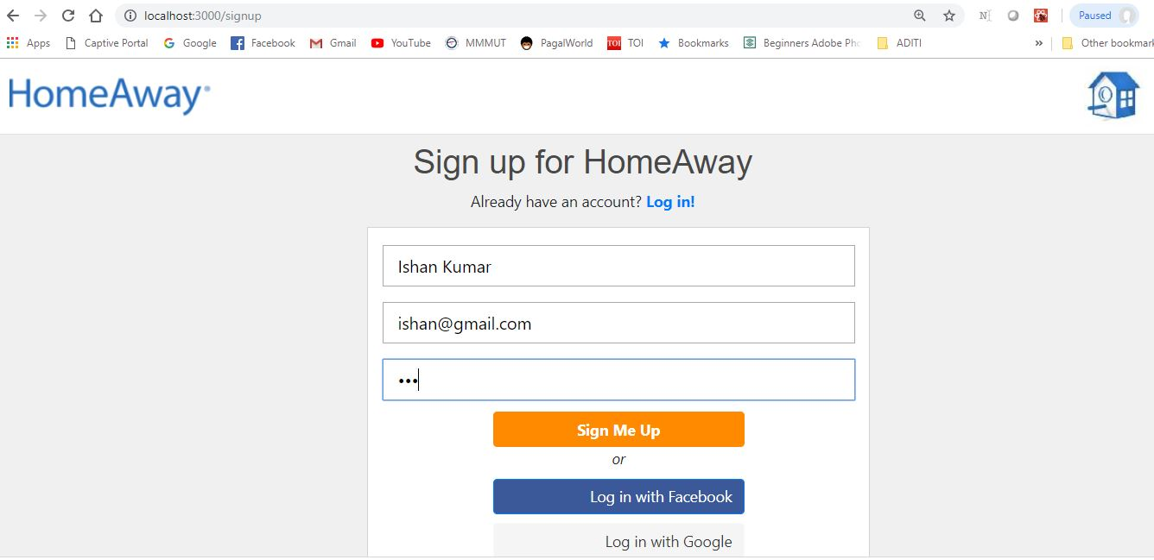

Route code:

Server output:

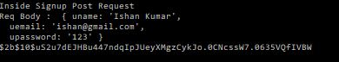

2) Login

User logging in:

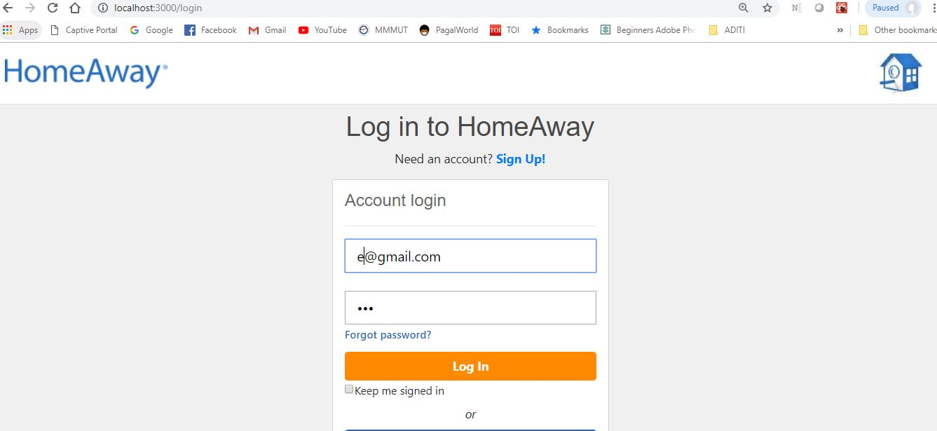

Route Code:

app.post('/login',function(req,res){

console.log("Inside Login Post Request");

console.log("Req Body : ",req.body);

var flag=0;

uemail=req.body.uemail;

upassword=req.body.upassword;

pool.getConnection(function(err,con) {

if (err)

throw err;

console.log("Connected!");

con.query('SELECT * FROM User WHERE email = ?',[uemail], function (error, results, fields) {

if (error) {

console.log("error ocurred",error);

res.send({

"code":400,

"failed":"error ocurred"

})

}else{

console.log('The solution is: ', results);

if(results.length >0){

if(bcrypt.compareSync(upassword,results[0].password))

{

console.log("Password matched")

flag=1;

}

// Start of error 2

else{

console.log("Errror point 2:Doesn't match")

res.send({

"code":204,

"failed":"Email and password does not match"

});

}

// end of error 2

}

else{

console.log("errror point 3:No such Email")

res.send({

"code":204,

"failed":"Email does not exits"

});

}

}

if (flag){

res.cookie('cookie',uemail,{maxAge: 900000, httpOnly: false, path : '/'});

console.log("below cookie")

console.log(results);

req.session.user = results;

console.log(req.session.user)

res.send({

"code":200,

"success":"login sucessfull"

});

}

//}

});

});

});

Server Output:

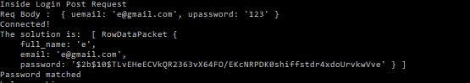

After successful login, redirected to home page where user can now search for property:

 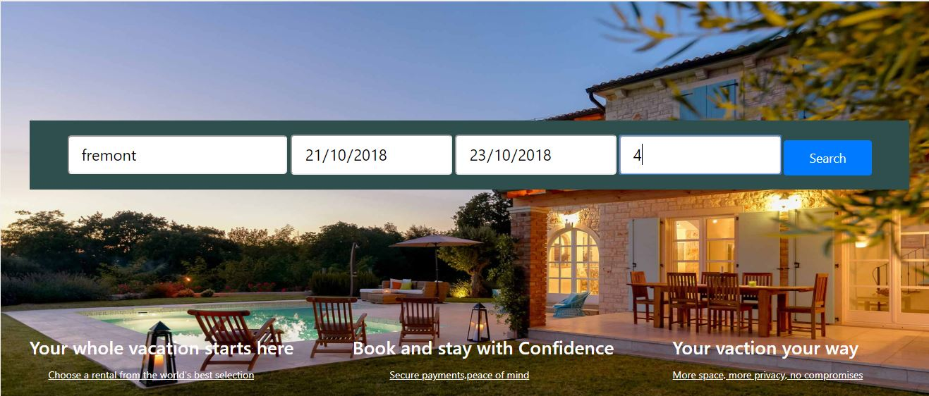

3) Update Profile

Profile being updated by User:

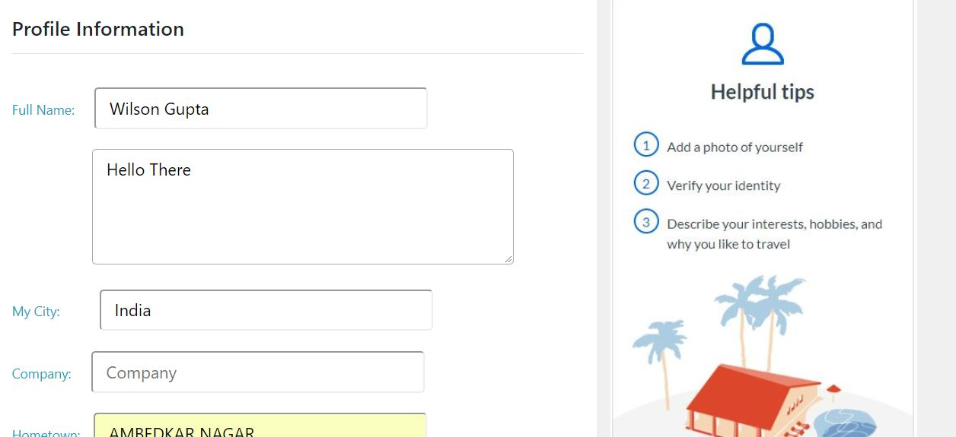

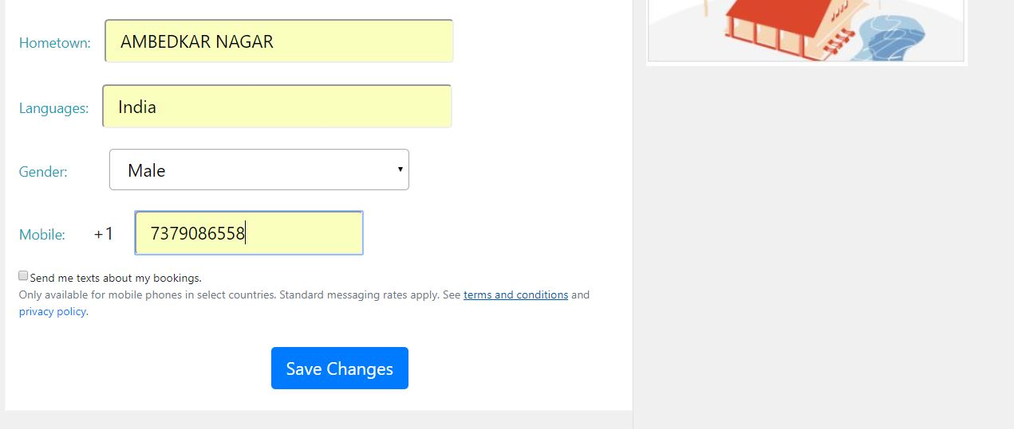

After Successful updation:

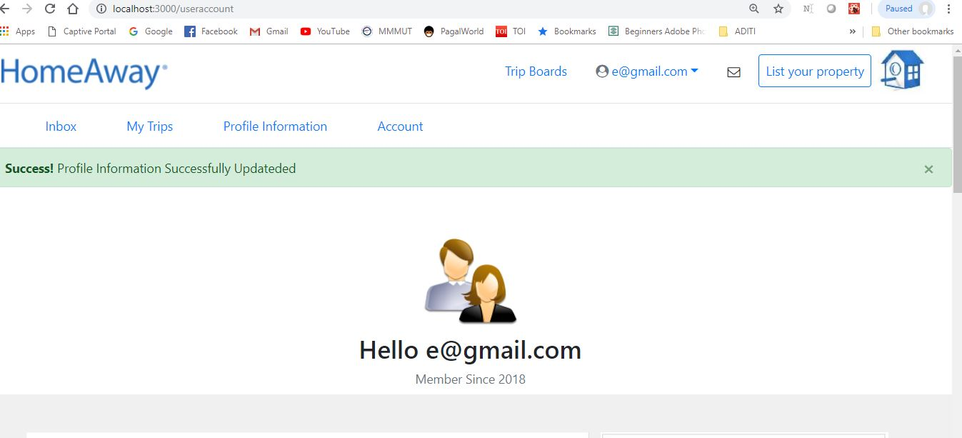

Route Code:

app.post('/udetails',function(req,res){

console.log("Inside Signup Post Request");

console.log("Req Body : ",req.body);

pool.getConnection(function(err,con) {

if (err)

throw err;

console.log("Connected!");

con.query('SELECT * FROM Udetails WHERE user_email = ?',[req.body.email], function (error, results, fields) {

if (error) {

console.log("error ocurred",error);

// res.send({

// "code":400,

// "failed":"error ocurred"

// })

//Start of else 2

}else{

if(results.length >0){

console.log("exists")

var sql="update Udetails SET fullname="+mysql.escape(req.body.fullname)+",aboutme=" +mysql.escape(req.body.aboutme)+",city="+mysql.escape(req.body.city)+",company="+mysql.escape(req.body.company)+",hometown="+mysql.escape(req.body.hometown)+",lang="+mysql.escape(req.body.language)+",gender="+mysql.escape(req.body.gender)+",phone="+mysql.escape(req.body.phone)+" WHERE user_email ="+mysql.escape(req.body.email)+";"

console.log(sql);

}

else{

var sql="insert into Udetails values("+mysql.escape(req.body.email)+","+mysql.escape(req.body.fullname)+"," +mysql.escape(req.body.aboutme)+","+mysql.escape(req.body.city)+","+mysql.escape(req.body.company)+","+mysql.escape(req.body.hometown)+","+mysql.escape(req.body.language)+","+mysql.escape(req.body.gender)+","+mysql.escape(req.body.phone)+");"

console.log(sql);

}

console.log(sql);

// Start of outer query

con.query(sql,function(err,result){

if(err){

console.log("Error inserting data")

res.send({

"code":400,

"failed":"error ocurred"

})

}

else{

console.log("Successful")

res.send({

"code":200,

"success":"login sucessfull"

});

}

});

// End of outer query

}

//End of else 2

});

});

});

Server output:

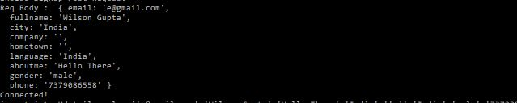

Once Profile information changed, changes will reflect after re-login:

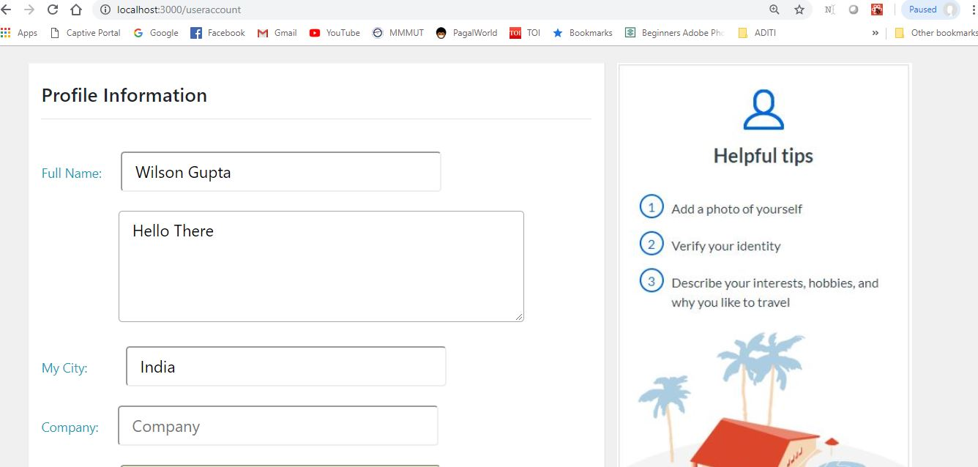

Database updated: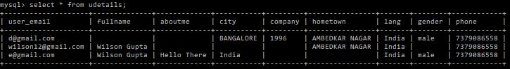

4) Search Property & Book Property

After successful login only, can be searched for property by user:



On clicking search button based on criteria result displayed:

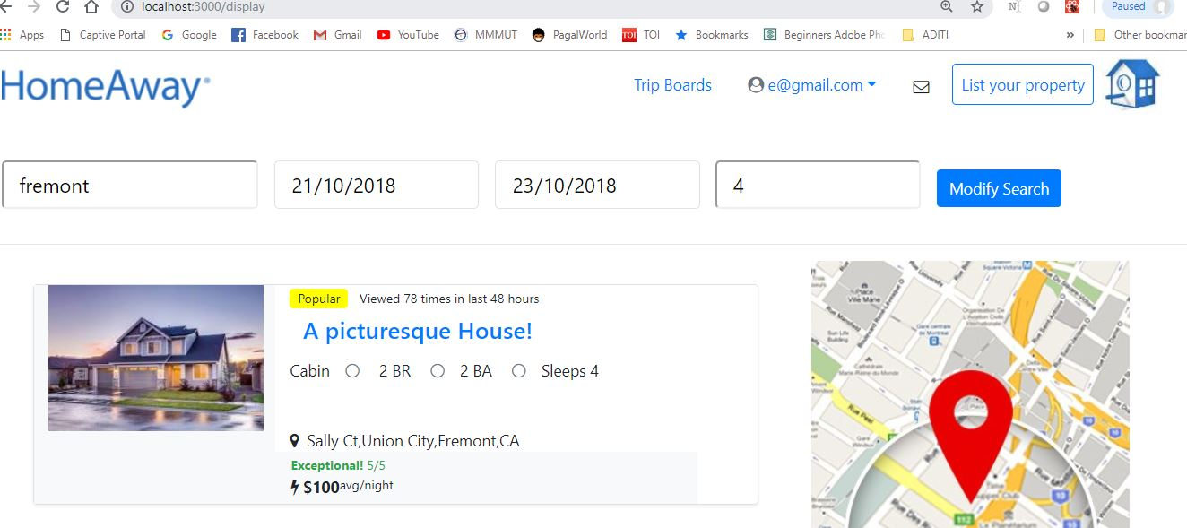

Route Code:

app.get('/demo/:id', function(req,res){

pool.getConnection(function(err,con) {

if (err)

throw err;

console.log("Connected!");

console.log(req.params.id)

var array = req.params.id.split("+");

console.log(array);

var sql = "SELECT * FROM property where accomodate="+mysql.escape(array[3])+"and property.location LIKE "+mysql.escape("%"+array[0]+"%")+"and"+mysql.escape(array[1])+">=property.startdate and"+mysql.escape(array[2])+"<=property.enddate and("+mysql.escape(array[2])+"<all(select bookdetails.startdate from property,bookdetails where property.id=bookdetails.id and bookdetails.location like"+mysql.escape("%"+array[0]+"%")+") or"+mysql.escape(array[1])+"> all(select bookdetails.enddate from property,bookdetails where property.id=bookdetails.id and bookdetails.location like"+mysql.escape("%"+array[0]+"%")+"));"

console.log(sql);

con.query(sql,function(err,result){

if(err){

console.log("error in search")

res.writeHead(400,{

'Content-Type' : 'text/plain'

})

res.end("Error while retrieving");

}else{

console.log("success search")

res.writeHead(200,{

'Content-Type' : 'application/json'

})

res.end(JSON.stringify(result));

}

});

});

})

Server Output:



Result changed on the basis of filter destination inside the display page:

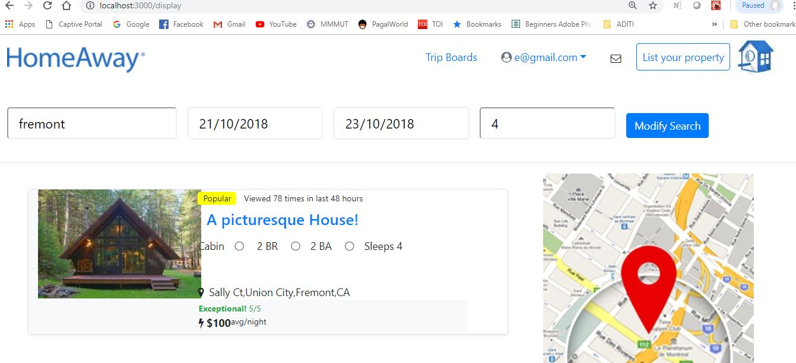

Server Output:



On clicking a particular property to **view full details** about the property:

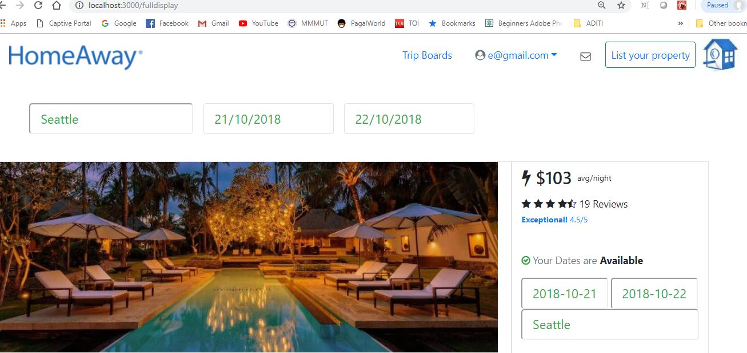

Server Output:



Detailed information of selected property:

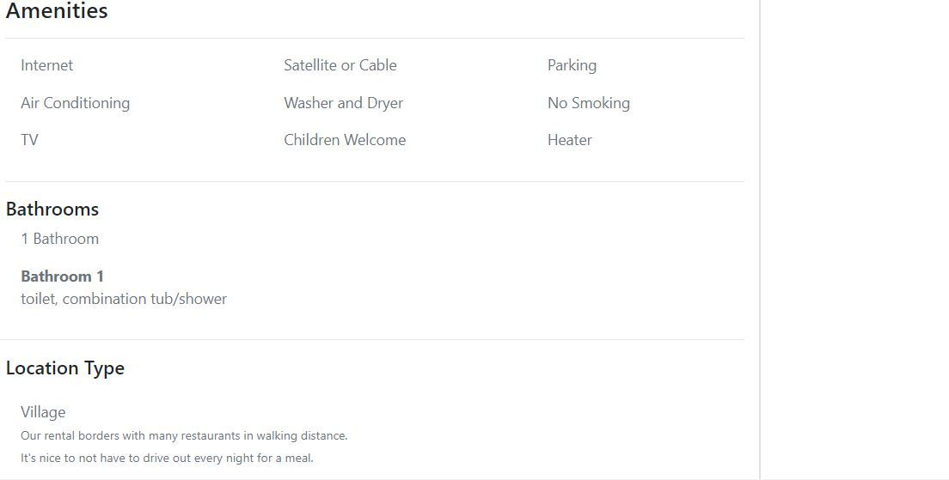

Route Code:

app.get('/fulldisplay/:id', function(req,res){

pool.getConnection(function(err,con) {

if (err)

throw err;

console.log("Connected!");

console.log(req.params.id)

var sql = "SELECT * FROM property where ID="+mysql.escape(req.params.id)+";"

// session_key like ?', '%' + value + '%', ...)

console.log(sql);

con.query(sql,function(err,result){

if(err){

console.log("error in search")

res.writeHead(400,{

'Content-Type' : 'text/plain'

})

res.end("Error while retrieving");

}else{

console.log("success search")

res.writeHead(200,{

'Content-Type' : 'application/json'

})

res.end(JSON.stringify(result));

}

});

});

})

Booking panel of the property:

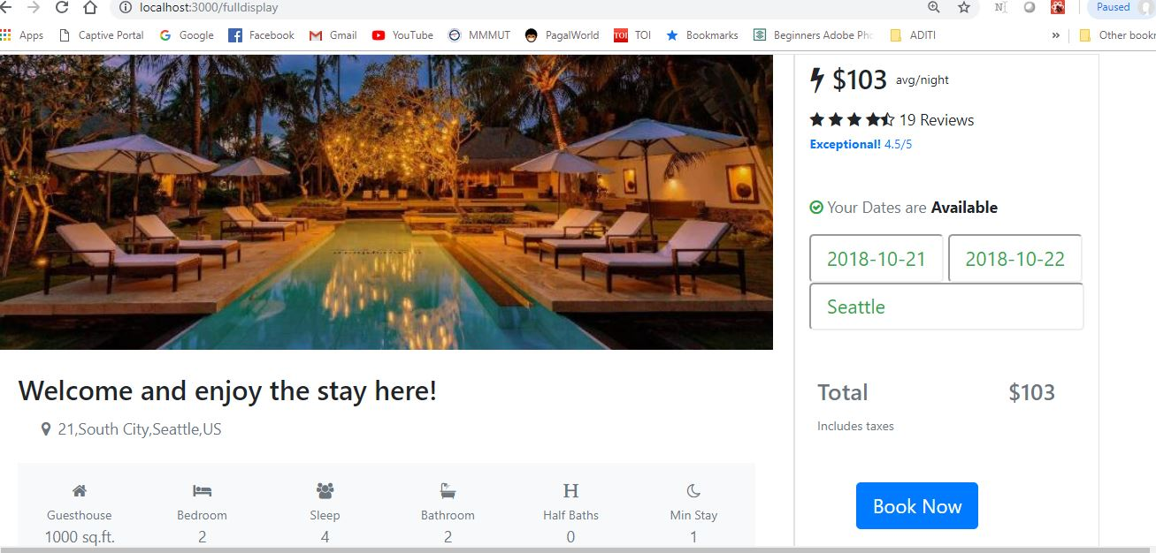

BOOKING:

When booking is successfully done:

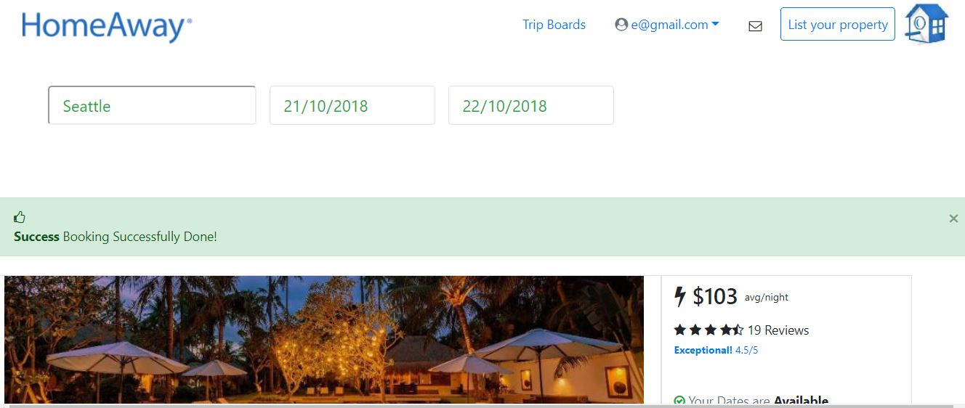

Route Code:

app.post('/makebook',function(req,res){

console.log("Inside Signup Post Request");

console.log("Req Body : ",req.body);

var sql="insert into bookdetails values("+mysql.escape(req.body.ownerid)+","+mysql.escape(req.body.useremail)+","+mysql.escape(req.body.startdate)+","+mysql.escape(req.body.enddate)+","+mysql.escape(req.body.destination)+");"

pool.getConnection(function(err,con) {

if (err)

throw err;

console.log("Connected!");

console.log(sql)

con.query(sql,function(err,result){

if(err){

console.log("Error inserting data")

res.send({

"code":400,

"failed":"error ocurred"

})

}

else{

console.log("Successful")

res.send({

"code":200,

"success":"login sucessfull"

});

}

});

});

});

Server Output:

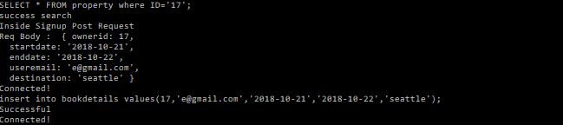

If again searched for same property for the dates already books, empty result:

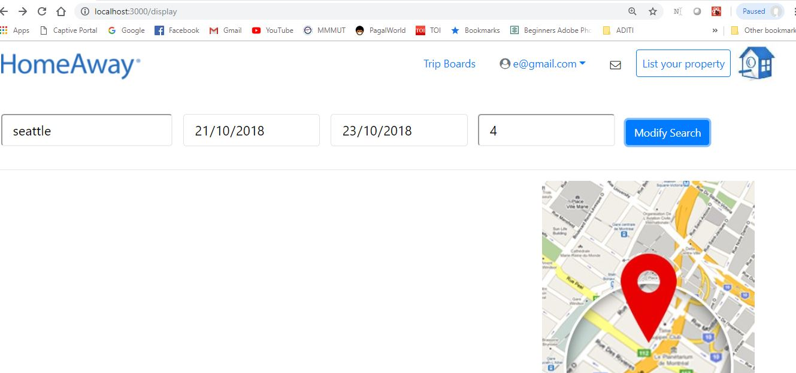

If travel date changed and property is available again appears in search result:

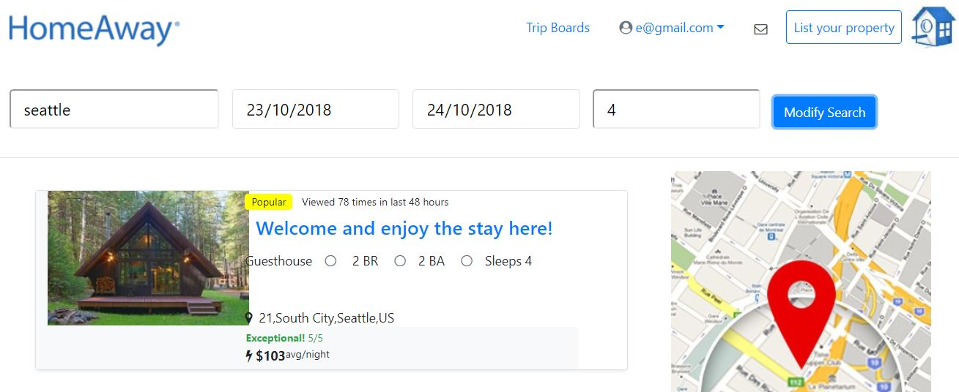

Booking History:

Viewing all the booked property by user:

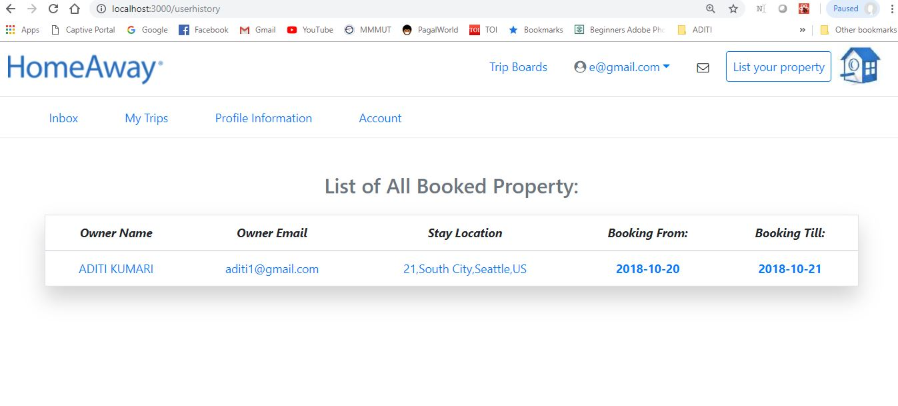

Route Code:

app.get('/userhistory/:id', function(req,res){

pool.getConnection(function(err,con) {

if (err)

throw err;

console.log("Connected!");

console.log(req.params.id)

var sql = "SELECT bookdetails.startdate,bookdetails.enddate,property.location,oemail,owner_name from bookdetails,property,owner where property.id=bookdetails.id and owner_email=property.oemail and useremail="+mysql.escape(req.params.id)+";"

console.log(sql);

con.query(sql,function(err,result){

if(err){

console.log("error in search")

res.writeHead(400,{

'Content-Type' : 'text/plain'

})

res.end("Error while retrieving");

}else{

console.log("success search")

res.writeHead(200,{

'Content-Type' : 'application/json'

})

res.end(JSON.stringify(result));

}

});

});

})

Server Output:

C:\Users\ADITI KUMARI\Desktop\screen\u31.JPG

**Questions And Answers:**

1.